Cap K Answers – GDS - 2024

Top Level

FW---Short---2AC

The roll of the ballot is to evaluate actualization of the plan vs. the alt--Key to rigorous testing--Any alternative interp harms fairness--Explodes limits- debate is a game so debatability comes first

Util---2AC

Utilitarianism is good and opposite of the logic of targeting---universal ethics counters violence because it doesn’t make a value statement on subject---relativist ethics turns the K
---alternatives to util turn the K---without universal principle---people sink into stereotypes which reproduce racism
---it doesn’t discriminate between individuals and primary goal is to stop suffering
---A2: Util = All lives matter---wrong, it makes BLM easier to understand and fight for because black people are disproportionately targeted
---turns any argument about killing those deemed unlivable of unable because the whole point of util is that attempts to devalue certain lives violates universal ethics
John Sweeney 18, Bowdoin Globalist, Why the Left Should Forget about Fairness, 2-27, https://bowdoinglobalist.com/2018/02/27/why-the-left-should-forget-about-fairness/ DOA: 8-31-18, y2k
Oprah might say that such a good is relative to our identity. Many people may agree, as they cheer her on when she speaks about living or speaking “your truth.” But we should not be concerned with my truth or your truth; rather, we should focus on the truth. The left should attempt to move away from the accommodation of moral relativism toward a pursuit of moral objectivity based on reason. Ascribing objectivity or scientific properties to morality strikes some people as presumptuous. In actuality, all that objective morality implies is that we have reason to prefer some moral theories over others and that we are right in saying that there are some things that we ought to do more than we ought to do other things. Much of the right’s political platform relies on the “moral truths” of Judeo-Christianity and the existence of natural rights. Although these principles are often paraded as objective truths, the particular religious dogmas or natural rights to which people subscribe do not find their basis in something as universal as reason. Most often they result from cultural myth or tradition, as people who wish to codify customs into inalienable or divine ethics spread their narrative. These stories frequently overlook reason or evidence and even attempt to undermine it in favor of faith. This is a terrible mistake. Without the universal principle of reason, people simply further internalize their sociocultural intuitions, sinking further into their given social norms, religious teachings, and stereotypes about others. Such thinking (or lack of thinking) has been largely responsible for enduring racism, sexism, speciesism, and the like, which have caused immeasurable suffering to conscious minds. Not only is ignoring reason undesirable; it is also impossible. If one were to disagree with this assertion, one would have to offer their own reason when asked why. Reason is our language of argumentation and thought (which is not to say that it is always best to be purely reasonable; we are not unfounded in our adoption of irrational dispositions at times). In reconstructing itself, the American left should embrace reason. This is more controversial than it might sound. It implies that the left confine itself to producing results that will improve conscious life, not fairness, unreasoned religious instructions, or vague principles such as equality or individuality. We must somehow navigate the landscape of the well-being of conscious entities; we must traverse the peaks and valleys between endless suffering and infinite joy. The left can realign itself with reality by forging this consequentialist path, standing against suffering and pursuing happiness. This objective morality is no more than an aggregation of subjective ones, seeking to maximize desirable feelings and minimize undesirable ones. Experiencing desirable feelings is subjective, yet we have objective reason to believe that these experiences exist and carry value (whereas we could not say the same thing about natural rights, free will, or religious afterlife). This universal perspective does not discriminate and encompasses all conscious creatures. Henry Sidgwick explains how this theory can lead us to greater unity: “the good of any one individual is of no more importance, from the point of view (if I may say so) of the Universe, than the good of any other; unless that is, there are special grounds for believing that more good is likely to be realised in the one case than in the other.” This should be the guiding maxim of the left. Applying consequentialism to a movement like Black Lives Matter makes both easier to conceptualize. Since the taking and harming of black lives is a disproportionate problem, we have special grounds for proclaiming “Black Lives Matter” rather than simply saying “All Lives Matter”. Such social movements need to be revised, as many Americans find them inherently divisive. Indeed, fifty-seven percent of Americans have a negative view of Black Lives Matter movement. By incorporating Sidgwick’s exception for functionality into his general claim that the good of every individual is of equal importance, the left can at once hope to tackle the political problems that are most pressing and remind us of our ultimate equal importance. Emphasis on particular lives, just like the government invention of rights, may be important means to maximizing happiness, but they are not declarations of innate value. By presenting these means as tools for the pursuit of happiness, the left can focus on the very concrete goal of improving sentient lives while fulfilling the most often ignored promise of our founders (“the pursuit of happiness” is often treated as a vague accessory to life and liberty). Consequentialism can also be an antidote to elitism, when we consider, as philosopher Jeremy Bentham did, that “the question is not Can they reason? nor Can they talk? but, Can they suffer? Why should the law refuse its protection to any sensitive being?” Bentham was talking about the problem of animal suffering, but the claim implicates all conscious life. A consequentialist framework would further some current objectives and create others for the left. We have already considered implications for how we talk about and act upon issues of criminal and racial justice. The consequentialist view also reconceives wealth as a means to flourishing rather than a deserved end reflecting a person’s worth (this mentality is so deeply ingrained in our culture that we often refer to future earnings as “our money” and any disruptive change to the system of wealth distribution, which is more than anything else responsible for our earnings, as a kind of theft). Psychologist Daniel Kahneman and economist Angus Deaton have famously found that positive correlations between individual income and happiness fail to appear at incomes above $75,000 a year. Considering this, although traditional consequentialism grants equality no innate value, practical applications of the theory would almost certainly be more egalitarian than the current policies of the political left. It would still be beneficial to have some wealth variation to facilitate incentives to contribute actively and positively to society, but the retention of wealth based on a primordial claim to it would cease to be a compelling rationalization of wealth inequality. A reexamination of moral values based on happiness should not confine itself to concern for any one species. Accordingly, the suffering that we inflict on billions of non-human animals every year (bundled with the economic inefficiency and environmental degradation that results from creating non-human animal products for human consumption) through meat production, non-human animal testing, and other harmful practices should be considered a major political problem. Extending concern to what some may consider a fringe issue may seem like a political impossibility. However, a growing number of people support all animal rights, as a third of Americans believe that non-human animals deserve the same rights and forty-four percent of Americans now oppose any medical testing on animals as humans. Furthermore, to ignore mass suffering of any kind denotes moral inconsistency. Humans tend to devalue the lives of those who are not like us, through racism, sexism, religious discrimination, and speciesism. All of these forms of bias are predicated on a deeply ingrained suspicion of others, a ruinous evolutionary remnant from a time when our base tribal allegiances were beneficial for our survival. The left has a chance to advocate for those among us who are most vulnerable: those who are unable to “speak their truth” to us. And doing so, contrary to popular belief, would not be political suicide. The most extreme caricatures of the left almost always hone in on its relativistic tendencies. The term “snowflake” is a response to the moral declaration of feelings, not facts. Accusations of “pie in the sky” policies, overly-sentimental approaches, and idealistic reasoning presume that the left is in some sense creating a reality for its political project instead of creating a political project for reality. Indiscriminate charges of racism and ad hominem attacks on political opponents fire up the liberal base yet defy the rules of rational engagement and alienate people whose political leanings depend on slight philosophical differences, shaped and reinforced by their biology and culture. The prevailing mentality on the left seems to be that Trump supporters do not deserve our consideration, open-minds, or reasoned conversations. Most Americans do not believe that the Democratic Party’s supposed inclusion extends to them. A recent Gallup poll found that the Republican Party’s favorability has stayed steady at thirty-nine percent since Trump’s presidential victory, while the Democratic Party’s favorability has dropped from forty-five percent to forty percent in that same time period. Perhaps the public senses hypocrisy. At the Democratic National Convention in July of 2016, Michelle Obama delivered a mantra for the anti-Trump left that many found inspiring: “when they go low, we go high.” In the fall, with less than a month left until the day that Donald Trump won the election for President of the United States (and with Hillary Clinton’s victory presumed to be a foregone conclusion), debate moderator Chris Wallace asked Donald Trump if he would be willing to accept the results of the upcoming presidential election. Trump declared that he would tell us at the time, which Hillary Clinton called “horrifying.” Yet despite the left’s attempts to take the moral high-ground in anticipation of a resounding victory in the US 2016 Presidential Election, once Trump’s presidency became a reality, many on the left abandoned such high hopes and principles. It seems the left should not have been so quick to demand the unconditional acceptance of the election results; ever since Trump’s victory, those on the left (and across the entire political spectrum) have tried to delegitimize Trump’s position by claiming that Russian interference is somehow responsible for his victory. This may be true, but it has become, like many of Trump’s political peculiarities, too much of a distraction. A Washington Post poll has found that more Americans believe the Democratic Party only stands against Trump than believe that the Democratic Party stands for something, by a margin of fifty-two percent to thirty-seven percent. The left still seems nostalgic for Obama’s sense of hope, even though they have been unable to craft their own inspirational theme. Far too many liberals are ready to follow Bill Maher’s declaration: “when they go low, you go lower.” But politics are still about hope, not despair. The left has just failed to present a unified and promising message. We are in the midst of a cultural realignment; massive shifts are inevitable. The choice that Democrats and those on the left now have is whether or not they will direct these changes toward consequences that maximize well-being. Politics can guide, limit, or ignore us on our journey through the moral landscape. Most of the left remains blinded like deer in headlights, either nonplussed by the prevailing partisan atrocity or naively fixated on the unfairness of their present situation. While the left may continue to stumble through the darkness, their vision obscured by concern for fairness, we must not forget: there is a moral compass ready to help guide us toward the pursuit of happiness. For the moment, it remains buried beneath our accommodationist ethics. But we shouldn’t be afraid to uncover it.

Consequentialism---Antitrust---2AC

It is impossible to distinguish the ideological intent of antitrust law – we must look to the consequences of future reform to determine positive intent
Crane 15 [DANIEL A. CRANE, Associate Dean for Faculty and Research and Frederick Paul Furth, Sr. Professor of Law, University of Michigan, RATIONALES FOR ANTITRUST: Economics and Other Bases, Chapter 1 of THE OXFORD HANDBOOK OF INTERNATIONAL ANTITRUST ECONOMICS Volume 1, poapst]
What are the purposes or objectives of the antitrust laws? There are several ways to answer this question. To answer it descriptively, one could look at the history of antitrust enforcement and ask who the antitrust laws have actually benefited or what they have achieved over time as they have been enforced. As the economist George Stigler wrote, “The announced goals of a policy are sometimes unrelated or perversely related to its actual effect and the truly intended effects should be deduced from the actual effects” (Stigler 1975, 140). The actual beneficiaries of antitrust enforcement may be quite different from those intended by the legislative framers of the antitrust statutes or the ones proposed by normative theorists. The answer to the descriptive question is contested. Public choice scholars have claimed that the history of US antitrust enforcers shows that small, inefficient businesses are the primary beneficiaries of antitrust enforcement, often at the expense of consumers and economic efficiency (McChesney and Shughart 1995). Many antitrust advocates would contest this claim and argue that consumers have been the primary beneficiaries of antitrust enforcement. In this chapter, I will not attempt to answer the empirical question. One could also attempt to answer the rationale question as a matter of legislative intent by looking to the intentions of the framers of the Sherman Act (1890) in the United States, the Treaty of Rome (1957), reborn in 2009 as the Treaty on the Functioning of the European Union (“TFEU”), or the foundational antitrust statute of any of the more than 100 nations that currently have antitrust laws. Such an approach is highly contestable too. Claims about the intentions of the framers of the Sherman Act, for example, have been controversial. The Chicago School theorist Robert Bork claimed to locate an economic efficiency objective in the congressional minds of 1890 (Bork 1978). Subsequent scholarship refuted Bork’s claim, finding the avoidance of wealth transfers from consumers to producers or protection of small, inefficient businesses to be the predominant legislative purposes (Lande 1982, DiLorenzo 1985, Hovenkamp 1988, Hazlett 1992). A third approach to determining antitrust rationales is to engage in a free-form normative debate about the role of monopoly, competition, law, and regulation in modern society. Should we have antitrust laws and, if so, why? This is where most of the action is today. Most scholars and antitrust practitioners—at least in the established antitrust regimes, particularly the United States and Europe—tend to assume that the foundational legal instruments creating antitrust law are sufficiently open-textured and subject to interpretation to accommodate a variety of different and sometimes conflicting normative objectives. Hence, the existential purposes of antitrust law are open for continued creation and recreation by litigants, scholars, judges, and government officials. Further, whoever have been the actual beneficiaries of antitrust law in the past, most antitrust practitioners assume that the proper beneficiaries can be reached if the right substantive norms, procedural rules, and institutional constraints are enacted. Thus, objections based on the past record of antitrust enforcement have largely fallen on deaf ears.

Offense

Cap Solves Climate---2AC

Cap solves climate change and alternatives only accelerate it
---dismantling systems isn’t easy takes time, means warming accelerates in the interim
---causes wars because it forces political upheaval and people will fight to keep capitalism which is both offense and means alt fails
---US has decreased emissions now, sustainable energy like wind, solar, and hydro solve, our ev cites a report that looked at over 7000 cases says sustainable is competitive and will be adopted universally in 10 years
---during transition in order to beat the system, the movement would have to massively ramp up emissions to build weapons which locks in warming
Smith 19 [Noah Smith Noah Smith is a Bloomberg Opinion columnist. He was an assistant professor of finance at Stony Brook University, and he blogs at Noahpinion, “Dumping Capitalism Won’t Save the Planet”, April 5, 2019, https://www.bloomberg.com/opinion/articles/2019-04-05/capitalism-is-more-likely-to-limit-climate-change-than-socialism, DOA: 8/20/19] Ian M
public-private cooperation will do more to limit climate change than eco-socialism. It has become fashionable on social media and in certain publications to argue that capitalism is killing the planet. Even renowned investor Jeremy Grantham, hardly a radical, made that assertion last year. The basic idea is that the profit motive drives the private sector to spew carbon into the air with reckless abandon. Though many economists and some climate activists believe that the problem is best addressed by modifying market incentives with a carbon tax, many activists believe that the problem can’t be addressed without rebuilding the economy along centrally planned lines. The climate threat is certainly dire, and carbon taxes are unlikely to be enough to solve the problem. But eco-socialism is probably not going to be an effective method of addressing that threat. Dismantling an entire economic system is never easy, and probably would touch off armed conflict and major political upheaval. In the scramble to win those battles, even the socialists would almost certainly abandon their limitation on fossil-fuel use — either to support military efforts, or to keep the population from turning against them. The precedent here is the Soviet Union, whose multidecade effort to reshape its economy by force amid confrontation with the West led to profound environmental degradation. The world's climate does not have several decades to spare. Even without international conflict, there’s little guarantee that moving away from capitalism would mitigate our impact on the environment. Since socialist leader Evo Morales took power in Bolivia, living standards have improved substantially for the average Bolivian, which is great. But this has come at the cost of higher emissions. Meanwhile, the capitalist U.S managed to decrease its per capita emissions a bit during this same period (though since the U.S. is a rich country, its absolute level of emissions is much higher). Doubting the Carbon-Capitalism Equation In other words, in terms of economic growth and carbon emissions, Bolivia looks similar to more capitalist developing countries. That suggests that faced with a choice of enriching their people or helping to save the climate, even socialist leaders will often choose the former. And that same political calculus will probably hold in China and the U.S., the world’s top carbon emitters — leaders who demand draconian cuts in living standards in pursuit of environmental goals will have trouble staying in power. The best hope for the climate therefore lies in reducing the tradeoff between material prosperity and carbon emissions. That requires technology — solar, wind and nuclear power, energy storage, electric cars and other vehicles, carbon-free cement production and so on. The best climate policy plans all involve technological improvement as a key feature. Recent developments show that the technology-centered approach can work. A recent report by Bloomberg New Energy Finance analyzed about 7000 projects in 46 countries, and found that large drops in the cost of solar power from photovoltaic systems, wind power and lithium-ion batteries have made utility-scale renewable electricity competitive with fossil fuels. A 76 percent decline in the cost of energy for short-term battery storage since 2012 is especially important. In a blog post, futurist and energy writer Ramez Naam underscores the significance of these developments. Naam notes the important difference between renewables being cheap enough to outprice new fossil-fuel plants, and being inexpensive enough to undercut existing plants. The former is already the case across much of the world, which is among the reasons for an 84 percent decrease in the number of new coal-fired plants worldwide since 2015. But when it becomes cheaper to scrap existing fossil-fuel plants and build renewables in their place, it will allow renewables to start replacing coal and gas much more quickly. Naam cites examples from Florida and Indiana where this is already being done. He cites industry predictions that replacing existing fossil-fuel plants with renewables will be economically efficient almost everywhere at some point in the next decade. Electricity is far from the only source of carbon emissions — there’s also transportation, manufacturing (especially of steel and cement), home and office heating, and agriculture to worry about. But the rapid advance of solar technology is a huge victory in the struggle against climate change, because it will allow people all over the world to have electricity without cooking the planet. And how was this victory achieved? A combination of smart government policy and private industry. Massachusetts Institute of Technology researchers Goksin Kavlak, James McNerney and Jessika Trancik in a recent paper evaluated the factors behind the solar-price decline from 1980 to 2012. They concluded that from 1980 to 2001, government-funded research and development was the main factor in bringing down costs, but from 2001 to 2012, the biggest factor was economies of scale. These economies of scale were driven by private industry increasing output, but with government subsidies helping to increase the incentive to ramp up production. It’s apparent, therefore, that both government and profit-seeking enterprises have their roles to play. Government funds the development of early-stage technology and then helps push the private sector toward adopting those technologies, while private companies compete to find ever-cheaper methods of implementation. Instead of eco-socialism, it’s eco-industrialism. If there’s any system that can beat climate change, this looks like it.

Cap Good/Transition Bad---2AC

Spreading capitalism creates global prosperity and environmental sustainability. Abandoning it is disastrous.
Rhonheimer, 20—teaching professor at the Pontifical University of the Holy Cross (Martin, “Capitalism is Good for the Poor – and for the Environment,” https://austrian-institute.org/en/subjects-en/catholic-social-doctrine-2/capitalism-is-good-for-the-poor-and-for-the-environment/, dml)

It is not social policy but capitalism that has created today’s prosperity.
What is important is that what made today’s mass prosperity possible – a phenomenon unprecedented in history – was not social policy or social legislation, organised trade union pressure, or corrective interventions in the capitalist economy, but rather market capitalism itself, due to its enormous potential for innovation and the ever-increasing productivity of human labour that resulted from it.
Increasing prosperity and quality of life are always the result of increasing labour productivity. Only increased productivity enabled higher social standards, better working conditions, the overcoming of child labour, a higher level of education, and the emergence of human capital. This process of increasing triumph over poverty and the constantly rising living standards of the general masses is taking place on a global scale – but only where the market economy and capitalist entrepreneurship are able to spread.
From industrial overexploitation of nature to ecological awareness
The first phase of industrialisation and capitalism was characterised by an enormous consumption of resources and frequent overexploitation of nature, which soon gave the impression that this process could not be sustainable. Since the end of the 19th century, disaster and doom scenarios have repeatedly been put forward, but in retrospect they have proved to be wrong: The combination of technological innovation, market competition, and entrepreneurial profit-seeking (with the compulsion to constantly minimise costs) have meant that these scenarios never occurred. The ever-increasing population has been increasingly better supplied thanks to innovative technologies, ever-increasing output with lower consumption of resources less harmful to the environment – e.g. less arable land in agriculture, or oil and electricity instead of coal for rapidly increasing mobility. More recent disaster scenarios, such as those spread by reputable scientists since the late 1960s and in the 1970s, have also proved to be inaccurate.
The reason things developed differently was the always underestimated innovative dynamism of the capitalist market economy, a growing ecological awareness and, as a result, legislative intervention that took advantage of the logic of market capitalism: As a result of the ecological movement that had come out of the United States since 1970, wise legislation began to use the price mechanism to apply market incentives to internalize negative externalities. Environmental pollution was given a price-tag.
This led to an enormous decrease in air pollution and other ecological consequences of growth, which is only possible in free, market-based societies, because the production process here is characterized by competition and constant pressure to reduce costs, i.e. to the most profitable use of resources. On the other hand, all forms of socialism, i.e. a state-controlled economy, have proved to be ecological disasters and have left behind destruction of gigantic proportions, without providing the population with anything that is near comparable in prosperity, often even by destroying existing prosperity, such as happened in Venezuela.
Capitalist profit motive combined with digitalization as a solution: Increasing decoupling of growth and resource consumption
Moreover, technological innovations combined with capitalist profit-seeking and market competition have led to a new and surprising phenomenon over the past decades, which is still hardly noticed in the public debate: the decoupling of growth and resource consumption (“dematerialization”). In a wide variety of industrial sectors, the developed countries, above all the U.S., are now achieving ever greater productive output with increasingly fewer resources. This has a lot to do with technology, especially the digitalization of the economy and of our entire lives.
As the well-known MIT professor Andrew McAfee shows in his book More from Less, published in October 2019, this process also follows the logic of capitalist profit maximization. To get it going, we do not need politics, even though wise, properly incentivizing legislation can be helpful and sometimes necessary. Above all, however, it is the combination of technological innovation, capitalist profit-seeking, and market-based entrepreneurial competition that will also solve the problem of man-made global warming.
In addition, property rights and their protection are decisive for the careful use of natural resources. And where this is not possible, legal support for collective self-governing structures, in accordance with the principle of subsidiarity, are important—as is analysed by Nobel Economic Prize winner Elinor Ostrom. By contrast, the growing ideologically motivated anti-capitalist eco-activism, and the policies influenced by it, are leading in the wrong direction, distracting precisely from what would be best for the climate and the environment—and distracting us from what could help protect us against the inevitable consequences of global warming.

Cap Solves War---2AC

The spread of capitalism causes world peace!
Mousseau, 19—Professor in the School of Politics, Security, and International Affairs at the University of Central Florida (Michael, “The End of War: How a Robust Marketplace and Liberal Hegemony Are Leading to Perpetual World Peace,” International Security, Volume 44, Issue 1, Summer 2019, p.160-196, dml)

Is war becoming obsolete? There is wide agreement among scholars that war has been in sharp decline since the defeat of the Axis powers in 1945, even as there is little agreement as to its cause.1 Realists reject the idea that this trend will continue, citing states' concerns with the “security dilemma”: that is, in anarchy states must assume that any state that can attack will; therefore, power equals threat, and changes in relative power result in conflict and war.2 Discussing the rise of China, Graham Allison calls this condition “Thucydides's Trap,” a reference to the ancient Greek's claim that Sparta's fear of Athens' growing power led to the Peloponnesian War.3
This article argues that there is no Thucydides Trap in international politics. Rather, the world is moving rapidly toward permanent peace, possibly in our lifetime. Drawing on economic norms theory,4 I show that what sometimes appears to be a Thucydides Trap may instead be a function of factors strictly internal to states and that these factors vary among them. In brief, leaders of states with advanced market-oriented economies have foremost interests in the principle of self-determination for all states, large and small, as the foundation for a robust global marketplace. War among these states, even making preparations for war, is not possible, because they are in a natural alliance to preserve and protect the global order. In contrast, leaders of states with weak internal markets have little interest in the global marketplace; they pursue wealth not through commerce, but through wars of expansion and demands for tribute. For these states, power equals threat, and therefore they tend to balance against the power of all states. Fearing stronger states, however, minor powers with weak internal markets tend to constrain their expansionist inclinations and, for security reasons, bandwagon with the relatively benign market-oriented powers.
I argue that this liberal global hierarchy is unwittingly but systematically buttressing states' embrace of market norms and values that, if left uninterrupted, is likely to culminate in permanent world peace, perhaps even something close to harmony. My argument challenges the realist assertion that great powers are engaged in a timeless competition over global leadership, because hegemony cannot exist among great powers with weak markets; these inherently expansionist states live in constant fear and therefore normally balance against the strongest state and its allies.5 Hegemony can exist only among market-oriented powers, because only they care about global order. Yet, there can be no competition for leadership among market powers, because they always agree with the goal of their strongest member (currently the United States) to preserve and protect the global order based on the principle of self-determination. If another commercial power, such as a rising China, were to overtake the United States, the world would take little notice, because the new leading power would largely agree with the global rules promoted and enforced by its predecessor. Vladimir Putin's Russia, on the other hand, seeks to create chaos around the world. Most other powers, having market-oriented economies, continue to abide by the hegemony of the United States despite its relative economic decline since the end of World War II.6
To support my theory that domestic factors determine states' alignment decisions, I analyze the voting preferences of members of the United Nations General Assembly from 1946 to 2010. I find that states with weak internal markets tend to disagree with the foreign policy preferences of the largest market power (i.e., the United States), but more so if they are major powers or have stronger rather than weaker military and economic capabilities. The power of states with robust internal markets, in contrast, appears to have no effect on their foreign policy preferences, as market-oriented states align with the market leader regardless of their power status or capabilities. I corroborate that this pattern may be a consequence of states' interest in the global market order by finding that states with higher levels of exports per capita are more likely than other states to have preferences aligned with those of the United States; those with lower levels of exports are more likely to have interests that do not align with the United States, but again more so if they are stronger rather than weaker.
Liberal scholars of international politics have long offered explanations for why the incidence of war may decline, generally beginning with the assumption that although the security dilemma exists, it can be overcome with the help of factors external to states.7 Neoliberal institutionalists treat states as like units and international organization as an external condition.8 Trade interdependence is dyadic and thus an external condition.9 Democracy is an internal factor, but theories of democratic peace have an external dimension: peace is the result of the expectations of states' behavior informed by the images that leaders create of each other's regime types.10 In contrast, I show that the security dilemma may not exist at all and how peace can emerge in anarchy with states pursuing their interests determined entirely by internal factors.11

Alternative

Transition Fails---2AC

Alt fails and no transition coming now---entrenched powerful resistance and cultural expectations of affluence means no one organizes and, to the extent that they do, they are ineffective
Alexander 16—Lecturer and research fellow at the University of Melbourne, co-director of the Simplicity Institute, and a PhD [Samuel, “Policies for a Post-Growth Economy,” Issues Paper No. 6 April 2016, p. 11, http://tinyurl.com/zq3vjn5]
Hard Truths about a ‘Top-Down’ Transition ¶ I wish to conclude by acknowledging several hard truths about the feasibility of a ‘top down’ transition to a post-growth economy. The first is to note that cultures around the world, especially in the developed world, are not close to being ready to take the idea of a post-growth economy seriously. In Australia, for example, our current and prospective governments are all firmly embedded in the growth paradigm and they show no signs of questioning it – none at all. At the cultural level, the expectation of ever-increasing affluence (which assumes continued growth) is as strong as ever. In this political and cultural context, the policy proposals outlined above – however necessary they might be to confronting the limits to growth predicament – will strike most people as wildly unrealistic, overly interventionist, and probably undesirable. I am not so deluded as to think otherwise.¶ The second point to note, subtly linked to the first, is that the powers-that-be would not tolerate these policies for a post-growth economy. To provide a case in point,when a relatively fringe Occupy Movement in 2011 began to challenge undue corporate influence on democracy and make noise about wealth inequality, soon enough the executive branches of government bore down upon the activists and stamped out the opposition. Mainstream media made little effort to understand the movement. Given that a postgrowth economy would directly undermine the economic interests of the most powerful corporations and institutions in society, one should expect merciless and sustained resistance from these vested interests if a post-growth movement ever began gaining ascendency.¶ The third point to note – and probably the most challenging – is that, in a globalised world order, even the bold policies proposed above would be unlikely to produce a stable and flourishing post-growth economy. After all, how would the stock markets react if a government announced a policy agenda that would deliberately aim to contract the economy for environmental and social justice reasons? More specifically, how would the stock markets react if a government, in pursuit of sustainability and global equity, introduced a diminishing resource cap that sought to phase out the most damaging industries and reduce resource consumption by 80% of current Australian levels? I suspect there would be utter turmoil, ultimately leading to an economic crash far greater than the global financial crisis. My point is that it may well be impossible to implement a smooth ‘top down’ transition to a post-growth economy, even if a strong social movement developed that wanted this. The market economies we know today would be unlikely to be able to adjust to the types and speed of foundational changes required. A ‘great disruption’ of some form may be a necessary or inevitable part of the transition beyond growth.¶ To make matters more challenging still, in a globalised economy, it is not clear whether a single nation could adopt a post-growth economy without inducing a range of antagonistic reactions from other nations. On the one hand, there is a web of international ‘free trade’ agreements that make such a move highly problematic, and could even provoke sanctions from international institutions or other governments. On the other hand, in a globalised economy there is always the threat of capital flight the moment a government threatens to defy the neoliberal logic of profit-maximisation or talks of wealth redistribution. There is also the geopolitical risk of being a leader in a post-growth transition, as this may involve fewer funds available for military forces,weakening a nation’s relative power globally. All of these issues radically call into question the feasibility of a ‘top down’ transition to a post-growth economy, and yet these challenges are rarely acknowledged in the post-growth literature.

A2: Alt---No Time---2AC

The alt locks in extinction if they’re right about environmental sustainability---there isn’t time for a global transition from capitalism and no certainty it ends emissions.
Polychroniou et al. '20 [CJ; 9/16/20; PhD in Political Science from the University of Delaware; Noam Chomsky, Professor & Professor of Linguistics emeritus at the Massachusetts Institute of Technology; Robert Pollin, Professor of Economics and Co-Director of the Political Economy Research Institute at the University of Massachusetts; "The Political Economy of Saving the Planet," https://bostonreview.net/science-nature-global-justice/noam-chomsky-robert-pollin-c-j-polychroniou-political-economy-saving]
There are important elements of truth in such views, but we should also be careful to not push this point too far. Some commentators have argued that one silver lining outcome of the pandemic was that, because of the economic lockdown, fossil fuel consumption and CO2 emissions plunged alongside overall economic activity during the recession. While this is true, I do not see any positive lessons here with respect to advancing a viable emissions program that can get us to net zero emissions by 2050. Rather, the experience demonstrates why a degrowth approach to emissions reduction is unworkable. Emissions did indeed fall sharply because of the pandemic and the recession. But that is only because incomes collapsed and unemployment spiked over this same period. This only reinforces the conclusion that the only effective climate stabilization path is the Green New Deal, as it is the only one that does not require a drastic contraction (or “degrowth”) of jobs and incomes to drive down emissions.
A genuinely positive development of the pandemic and recession is that progressive activists around the world have fought to include Green New Deal investments in their countries’ economic stimulus programs. It is critical to keep pushing the development and success of these initiatives.
In support of that end, we must seriously consider how to best maximize both the short-term stimulus benefits and long-term impacts of Green New Deal programs. I know the importance of such considerations from personal experience working on the green investment components of the 2009 Obama American Recovery and Reinvestment Act, in which $90 billion of the $800 billion total was allocated to clean energy investments in the United States. The principles underlying these investment components were sound, but the people who worked on the program in its various stages, including myself, did not adequately calculate the time necessary to execute many of the projects. We knew that it was critical to identify “shovel-ready” projects—ones that could be quickly implemented on a large scale and provide an immediate economic boost. But relatively few green investment projects were truly shovel-ready at that time, as the green energy industry was still a newly emerging enterprise. Therefore, the backlog of significant new projects was thin. It is only moderately less thin today.
This means that people designing Green New Deal stimulus programs must identify the subgroup of green investment projects that can realistically roll into action at scale within a matter of months. One example that should be applicable in almost every country would be energy efficiency retrofits of all public and commercial buildings. This would entail improving insulation, sealing window frames and doors, switching over all lightbulbs to LEDs, and replacing aging heating and air conditioning systems with efficient ones (preferably heat pumps). These programs could quickly generate large numbers of jobs for secretaries, truck drivers, accountants, construction workers, and climate engineers. They could also save energy and reduce emissions quickly and relatively cheaply. Building off of such truly shovel-ready projects, the rest of the clean energy investment program could then accelerate and provide a strong foundation for economies moving out of recession and onto a sustainable recovery path.
CP: Eco-socialism is becoming a major tenet of the ideological repertoire of green parties in European countries and elsewhere, which may be the reason for their increasing appeal with voters and especially the youth. Is eco-socialism a cohesive enough political project to be taken seriously as an alternative for the future?
NC: Insofar as I understand eco-socialism—not in great depth—it overlaps greatly with other left socialist currents. That being said, I don’t think we’re at a stage where adopting a specific “political project” is very helpful. There are crucial issues that have to be addressed, right now. Our efforts should be informed by the kind of future society that we want, and the kind that can be constructed within our existing society. It’s fine to stake out specific positions about the future in more or less detail, but for now these seem to me at best ways of sharpening ideas rather that platforms to latch on to.
A good argument can be made that inherent features of capitalism lead inexorably to the ruin of the environment, and that ending capitalism must be a priority of the environmental movement. But there’s one fundamental problem with this argument: time scales. Dismantling capitalism is impossible in the time frame that we have for taking urgent action, which requires national and international mobilization if severe crisis is to be averted.
Furthermore, the whole discussion around eco-socialism is misleading. The two efforts—averting environmental disaster, and dismantling capitalism in favor of a freer and more just society—should and can proceed in parallel. One example is Tony Mazzocchi’s efforts to forge a labor coalition that would not only challenge owner-management control of the workplace, but also be at the forefront of the environmental movement while attempting to socialize major sectors of U.S. industry. There’s no time to waste. The struggle must be, and can be, undertaken on all fronts.
CP: Bob, in your view, can eco-socialism coexist with the Green New Deal project? And, if not, what type of a politico-ideological agenda might be needed to generate broad political participation in the struggle to create a green future?
RP: In my view, details of rhetoric and emphasis aside, eco-socialism and the Green New Deal are fundamentally the same project. The Green New Deal, as we have discussed the term, offers the only path to climate stabilization that can also expand good job opportunities and raise living standards in all regions of the world. It defines an explicit and viable alternative to austerity economics on a global scale. My coworkers and I have worked on this issue—advancing the Green New Deal as an alternative to austerity economics—in different country settings over the past few years, including in Spain, Puerto Rico, and Greece. In my view, the Green New Deal is the only approach to climate stabilization also capable of reversing rising inequality and defeating global neoliberalism and ascendant neofascism.
Beyond the Green New Deal, I don’t know what exactly “eco-socialism” could mean. Does it mean the overthrow of all private ownership of productive assets for public ownership? As Noam suggested, do people seriously think that this could happen within the time frame we have to stabilize the climate, that is, within less than thirty years? And are we certain that eliminating all private ownership would be workable or desirable from a social justice standpoint—i.e. from the standpoint of advancing well-being for the global working class and poor? How do we deal with the fact that most of the world’s energy assets are already publicly owned? How, more specifically, can we be certain that a transition to complete public ownership would itself deliver zero net emissions by 2050? To me, the overarching challenge is trying to understand alternative pathways to most effectively building truly egalitarian, democratic, and ecologically sustainable societies—putting all labels aside and being willing, as Marx himself insisted, to employ “ruthless criticism” toward all that exists, including all past experiences with Communism and Socialism. And, for that matter, being open to criticizing all authors, including Marx himself. Indeed, my favorite quote from Marx is “I am not a Marxist.”

A2: Alt---Transition Wars---2AC

Alt fails---transition wars and domestic pressure means the alt abandons fidelity to the environment.
Smith '19 [Noah; 4/5/19; Bloomberg Opinion columnist, former assistant professor of finance at Stony Brook University; "Dumping Capitalism Won’t Save the Planet," https://www.bloomberg.com/opinion/articles/2019-04-05/capitalism-is-more-likely-to-limit-climate-change-than-socialism]
It has become fashionable on social media and in certain publications to argue that capitalism is killing the planet. Even renowned investor Jeremy Grantham, hardly a radical, made that assertion last year. The basic idea is that the profit motive drives the private sector to spew carbon into the air with reckless abandon. Though many economists and some climate activists believe that the problem is best addressed by modifying market incentives with a carbon tax, many activists believe that the problem can’t be addressed without rebuilding the economy along centrally planned lines.
The climate threat is certainly dire, and carbon taxes are unlikely to be enough to solve the problem. But eco-socialism is probably not going to be an effective method of addressing that threat. Dismantling an entire economic system is never easy, and probably would touch off armed conflict and major asdasd upheaval. In the scramble to win those battles, even the socialists would almost certainly abandon their limitation on fossil-fuel use — either to support military efforts, or to keep the population from turning against them. The precedent here is the Soviet Union, whose multidecade effort to reshape its economy by force amid confrontation with the West led to profound environmental degradation. The world's climate does not have several decades to spare.
Even without international conflict, there’s little guarantee that moving away from capitalism would mitigate our impact on the environment. Since socialist leader Evo Morales took power in Bolivia, living standards have improved substantially for the average Bolivian, which is great. But this has come at the cost of higher emissions. Meanwhile, the capitalist U.S managed to decrease its per capita emissions a bit during this same period (though since the U.S. is a rich country, its absolute level of emissions is much higher).
In other words, in terms of economic growth and carbon emissions, Bolivia looks similar to more capitalist developing countries. That suggests that faced with a choice of enriching their people or helping to save the climate, even socialist leaders will often choose the former. And that same political calculus will probably hold in China and the U.S., the world’s top carbon emitters — leaders who demand draconian cuts in living standards in pursuit of environmental goals will have trouble staying in power.
The best hope for the climate therefore lies in reducing the tradeoff between material prosperity and carbon emissions. That requires technology — solar, wind and nuclear power, energy storage, electric cars and other vehicles, carbon-free cement production and so on. The best climate policy plans all involve technological improvement as a key feature.

Root Cause

A2: Root Cause---2AC

No root cause---particulars of each case must be accounted for
Azar Gat 9, Chair of the Department of Political Science at Tel Aviv University, “So Why Do People Fight? So Why Do People Fight? Evolutionary Theory and the Causes of War”, European Journal of International Relations 2009 15: 571-599
This article’s contribution is two-pronged: it argues that IR theory regarding the causes of conflict and war is deeply flawed, locked for decades in ultimately futile debates over narrow, misconstrued concepts; this conceptual confusion is untangled and the debate is transcended once a broader, comprehensive, and evolutionarily informed perspective is adopted. Thus attempts to find the root cause of war in the nature of either the individual, the state, or the international system are fundamentally misplaced. In all these ‘levels’ there are necessary but not sufficient causes for war, and the whole cannot be broken into pieces.13 People’s needs and desires — which may be pursued violently — as well as the resulting quest for power and the state of mutual apprehension which fuel the security dilemma are all molded in human nature (some of them existing only as options, potentials, and skills in a behavioral ‘tool kit’); they are so molded because of strong evolutionary pressures that have shaped humans in their struggle for survival over geological times, when all the above literally constituted matters of life and death. The violent option of human competition has been largely curbed within states, yet is occasionally taken up on a large scale between states because of the anarchic nature of the inter-state system. However, returning to step one, international anarchy in and of itself would not be an explanation for war were it not for the potential for violence in a fundamental state of competition over scarce resources that is imbedded in reality and, consequently, in human nature. The necessary and sufficient causes of war — that obviously have to be filled with the particulars of the case in any specific war — are thus as follows: politically organized actors that operate in an environment where no superior authority effectively monopolizes power resort to violence when they assess it to be their most cost-effective option for winning and/or defending evolution-shaped objects of desire, and/or their power in the system that can help them win and/or defend those desired goods.

Impacts

A2: Environment---War Turns---2AC

War turns the kritik---obliterates the environment.
Mercer 21 [Matthew; 5/13/21; writer for Red Flag; "How militarism is killing the planet," https://redflag.org.au/article/how-militarism-killing-planet/]
Military production depends on the consumption of large quantities of fossil fuels and involves countless other environmentally destructive processes. The mining, refining and production of some of the key resources employed in military production, like aluminium, steel and nickel, are highly energy intensive, producing massive emissions of carbon dioxide and other greenhouse gases.
Over half the energy required for aluminium smelting is currently produced by burning coal, and the perfluorocarbons released during the smelting process are between 6,500 and 9,200 times more potent as drivers of global warming than carbon dioxide. Nickel mining emits millions of tonnes of toxic sulphur dioxide per year, and has a history of severe pollution of the land, air and water surrounding mines—such as when a major spill from the Norilsk nickel factory in Russia turned the Daldykan river bright red in 2016.
Steel production contributes 3.3 billion tonnes annually to global carbon emissions. The iron and steel industries are estimated by the International Energy Agency to be responsible for around 6.7 percent of the world’s total carbon dioxide emissions.
Then there are nuclear weapons. Even if we discount the possibility that the thousands of nuclear warheads currently armed and ready to deploy around the world will one day lead to the destruction of all human civilisation, we must factor in the poisonous industry that produces them. Whatever the industry’s backers might say, the risks involved in mining uranium, producing power in nuclear reactors and dealing with radioactive waste are all too obvious from the history of highly destructive accidents—from the Ranger uranium mine spill in 2013, to the catastrophic meltdowns at Chernobyl and Fukushima.
The US military is both the world’s single largest consumer of fossil fuels and its largest producer of carbon emissions. The five largest US chemical companies combined produce only a fifth of the military’s emissions.
Multiple studies show a correlation between states’ increased military spending and high emissions. Armies internationally are also responsible for two-thirds of global emissions of chlorofluorocarbons—a volatile derivative of methane that, in addition to contributing to global warming, destroys the ozone layer that protects Earth from damaging ultraviolet light (a major cause of skin cancer). These substances were banned under the 1987 Montreal Protocol, but the military use of them goes on.
And all this concerns only the day to day “peacetime” operations of the military. War itself, as well as killing, maiming and destroying human lives, is catastrophic for the environment, flattening landscapes and poisoning the air.
Environmental destruction can be a conscious tool of warfare. During the Vietnam War, the US sprayed an estimated 20 million gallons of the chemical defoliant Agent Orange across the country in order to clear forest canopies providing cover to North Vietnamese and Viet Cong troops and to cripple agriculture. The toxic effects of Agent Orange on Vietnam’s environment, farming and human life continue to today.
Even when not purposefully destroying nature, warfare causes irreparable environmental damage. The US bombing campaigns in Iraq in the 1990s and 2000s created extensive pollution and environmental degradation. The use of ammunition tipped with depleted uranium contaminated possibly tens of thousands of hectares of Iraqi land and led to elevated levels of birth defects in communities where the bombing was most intense.
And the initial destruction wrought by wars has massive roll-on effects. After the 1991 Gulf War and 2003 US invasion, cases of typhoid increased tenfold among the Iraqi population as a result of water pollution due to the destruction of sewage systems and other basic infrastructure.
Similar damage occurred in Afghanistan. Already in 2003, just two years into a war that has now dragged on for two decades, a United Nations Environment Programme report found that the war, combined with a lengthy drought, had “caused serious and widespread land and resource degradation, including lowered water tables, desiccation of wetlands, deforestation and widespread loss of vegetative cover, erosion, and loss of wildlife populations”.

A2: Inequality---2AC

Inequality is decreasing at unprecedented rates by every metric.
McAfee, 19—cofounder and codirector of the MIT Initiative on the Digital Economy at the MIT Sloan School of Management, former professor at Harvard Business School and fellow at Harvard’s Berkman Center for Internet and Society (Andrew, “The Global Gallop of the Four Horsemen,” More from Less: The Surprising Story of How We Learned to Prosper Using Fewer Resources—and What Happens Next, Chapter 10, pg 235-240, Kindle, dml)

In 2016 the economist and columnist Noah Smith reviewed the evidence on poverty around the world, and his conclusion was notably exuberant: "This is incredible—nothing short of a miracle. Nothing like this has ever happened before in recorded history." A graph created by Max Roser clearly reveals the "miracle" Smith was talking about, and how right he was that the improvement is without precedent. The graph doesn't show the percentage of people living in poverty, but instead something even more important: the total number of extremely poor people on earth.
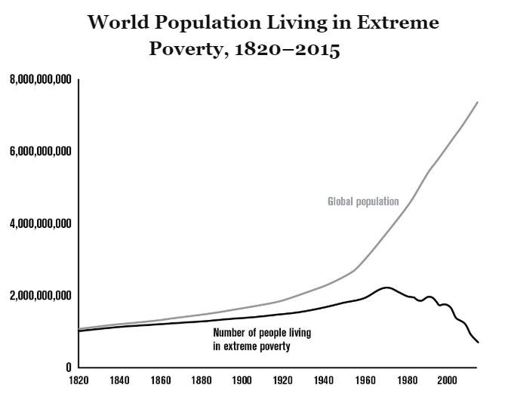
The World's War on Poverty
The total number of poor people in the world peaked right at the time of the first Earth Day in 1970, then started to slowly decrease. But the real miracle came when this happy decline accelerated during the twenty- first century. In 1999, 1.76 billion people were living in extreme poverty. Just sixteen years later, this number had declined by 60 percent, to 705 million. Hundreds of millions fewer people are living in poverty now than in 1820, when the world's total population was seven times smaller than it is today.
Much of this decline is reflective of what occurred in China, which, as we saw in the previous chapter, threw off economic socialism beginning in 1978 and let capitalism work its poverty-reducing miracles. But the story of global poverty reduction isn't a purely Chinese one. As the graph below shows, every region around the world has seen large poverty reductions in recent years. The speed of the recent decline indicates that it's no longer ridiculous to talk about completely eliminating extreme poverty from the planet. The World Bank thinks this might be possible by 2030.
It's not just incomes that have improved. As I consult Our World in Data and other comprehensive sources of evidence, I struggle to find even a single important measure of human material well-being that's not getting better in most regions around the world.
Here are recent trends in a few key areas.
Daily Bread
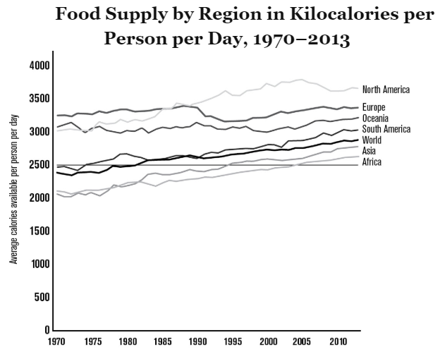
As recently as 1980, the global average number of available daily calories wasn't enough to permit an active adult male to maintain his body weight. Less than thirty-five years later, however, every region in the world met this standard of twenty-five hundred daily calories.
Clean Living
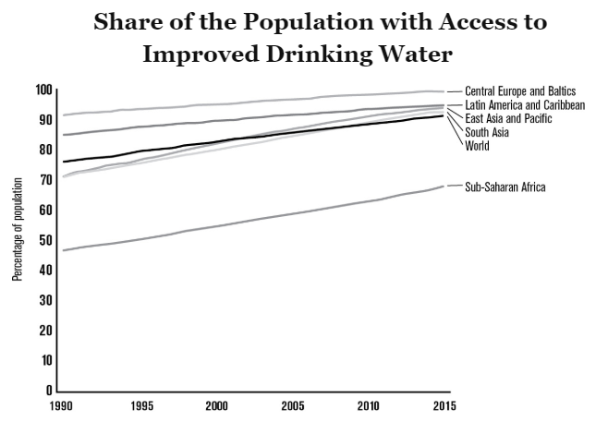
More than 90 percent of the world's people now have access to improved water;VII in 1990 only a bit more than 75 percent did. The situation is similar for sanitation: in 1990 only a bit more than half of the world's people had it; now, more than two-thirds do.
Young Minds
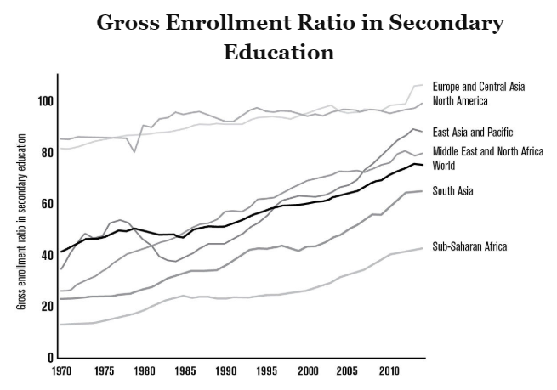
The trend in secondary education enrollment around the world is similar to the one for sanitation, but even sharper: in 1986 fewer than half of the world's teenagers were in school; at present, more than 75 percent are.
One Thing We Say to Death: Not Today
By now the pattern should be familiar: life expectancy at birth has gone up around the world in recent decades:
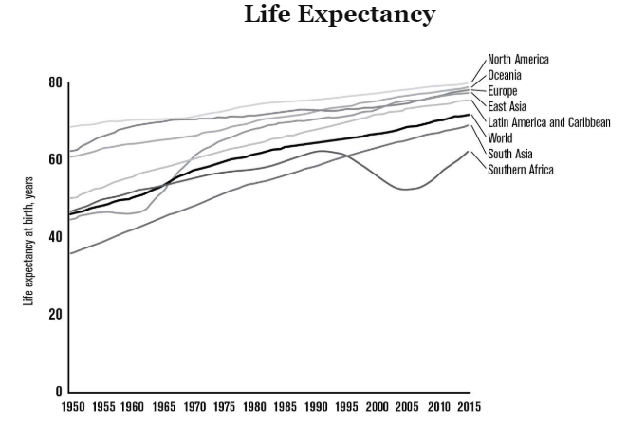
As we saw in chapter 1, global life expectancy was about 28.5 years in 1800. Over the next 150 years, that number increased by 20 years. Then, in the years between 1950 and 2015, it increased by 25 more. These gains are now universal; Southern Africa has regained the 10 years of expected life lost during its terrifying AIDS crisis.
One of the reasons life expectancy has gone up so quickly is the collapse in both child and maternal mortality around the world:
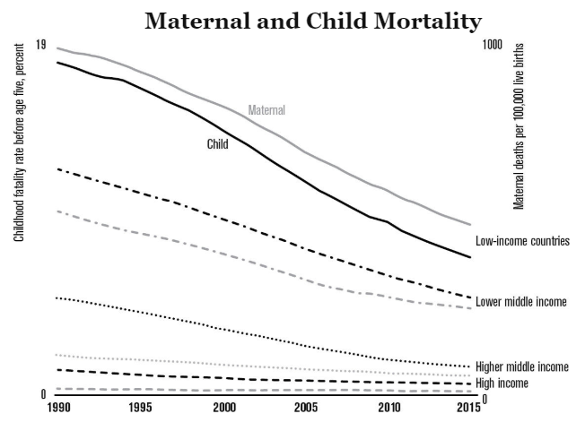
I find these mortality declines especially fast, large, and broad. Today, we still have desperately poor regions, failed states, and the decimations of war. But in no region today is the child mortality rate higher than the world's average rate was in 1998.
Convergent
Trends in maternal and child mortality highlight a critical fact that's often overlooked: around the world, inequality in most important measures of human material well-being is decreasing. Poor countries are catching up to rich ones, and gaps that were once large are shrinking. Inequalities in income and wealth dominate the news, and in many places these gaps are large and growing. They re also important, so well look at economic inequality in the next two chapters.
But it's true, too, that there are other kinds of inequality that we should care about as we examine the human condition: inequalities in health, education, diet, sanitation, and other things that matter deeply for the quality of a person's life. Here the news is profoundly good; these inequalities are collapsing. As the four horsemen have galloped around the world in recent decades, they've made life better not only for those people and countries that were already rich but for just about everyone else. Everywhere, fewer mothers and babies are dying, more kids are getting an education, more people have adequate nutrition and sanitation.
It's essential to acknowledge these global victories because they show us that what we're doing is working. Tech progress, capitalism, public awareness, and responsive government are spreading around the world and improving it. It's often said that insanity is doing the same thing over and over but expecting different results. The corollary might be that ignorance is not examining the results of what's being done. Over and over, when we look at the evidence, we see that the four horsemen are improving our world.

Sustainability

Sustainability---2AC

Growth is sustainable.
Harford, 20—economics columnist for the Financial Times, citing Diane Coyle, Bennett Professor of Public Policy at the University of Cambridge, Vaclav Smil, Distinguished Professor Emeritus in the Faculty of Environment at the University of Manitoba, Chris Goodall, English businessman, author and expert on new energy technologies, alumnus of St Dunstan's College, University of Cambridge, and Harvard Business School, and Jesse Ausubel, Director and Senior Research Associate of the Program for the Human Environment of Rockefeller University (Tim, “Two cheers for the dematerialising economy,” https://www.ft.com/content/04858216-322e-11ea-9703-eea0cae3f0de, dml)

If past trends continue, the world’s gross domestic product will be about twice as big by 2040 as it is today. That’s the sort of growth rate that translates to 30-fold growth over a century, or by a factor of a thousand over two centuries.
Is that miraculous, or apocalyptic? In itself, neither. GDP is a synthetic statistic, invented to help us put a measuring rod up against the ordinary business of life. It measures neither the energy and resource consumption that might worry us, nor the things that really lead to human flourishing.
That disconnection from what matters might be a problem if politicians strove to maximise GDP, but they don’t — otherwise they would have hesitated before imposing austerity in the face of a financial crisis, launching trade wars or getting Brexit done. Economic policymaking has flaws, but an obsession with GDP is not one of them.
Nevertheless the exponential expansion of GDP is indirectly important, because GDP growth is correlated with things that do matter, good and bad. Economic growth has long been associated with unsustainable activities such as carbon dioxide emissions and the consumption of metals and minerals.
But GDP growth is also correlated with the good things in life: in the short run, an economy that is creating jobs; in the long run, more important things. GDP per capita is highly correlated with indicators such as the Social Progress Index. The SPI summarises a wide range of indicators from access to food, shelter, health and education to vital freedoms of choice and from discrimination. All the leading countries in the Social Progress database are rich. All the strugglers are desperately poor.
So the prospect of a doubling of world GDP matters, not for its own sake, but for what it implies — an expansion of human flourishing, and the risk of environmental disaster.
So here’s the good news: we might be able to enjoy all the good stuff while avoiding the unsustainable environmental impact. The link between economic activity and the use of material resources is not as obvious as one might think. There are several reasons for this.
The first is that for all our seemingly insatiable desires, sometimes enough is enough. If you live in a cold house for lack of money, a pay rise lets you take off the extra cardigan and turn up the radiators. But if you win the lottery, you are not going to celebrate by roasting yourself alive.
The second is that, while free enterprise may care little for the planet, it is always on the lookout for ways to save money. As long as energy, land and materials remain costly, we’ll develop ways to use less. Aluminium beer cans weighed 85 grammes when introduced in the late 1950s. They now weigh less than 13 grammes.
The third reason is a switch to digital products — a fact highlighted back in 1997 by Diane Coyle in her book The Weightless World. The trend has only continued since then. My music collection used to require a wall full of shelves. It is now on a network drive the size of a large hardback book. My phone contains the equivalent of a rucksack full of equipment.
Dematerialisation is not automatic, of course. As Vaclav Smil calculates in his new book, Growth, US houses are more than twice as large today as in 1950. The US’s bestselling vehicle in 2018, the Ford F-150, weighs almost four times as much as 1908’s bestseller, the Model T. Let’s not even talk about the number of cars; Mr Smil reckons the global mass of automobiles sold has increased 2,500-fold over the past century.
Still, there is reason for hope. Chris Goodall’s research paper “Peak Stuff” concluded that, in the UK, “both the weight of goods entering the economy and the amounts finally ending up as waste probably began to fall from sometime between 2001 and 2003”. That figure includes the impact of imported goods.
In the US, Jesse Ausubel’s article “The Return of Nature” found falling consumption of commodities such as iron ore, aluminium, copper, steel, and paper and many others. Agricultural land has become so productive that some of it is being allowed to return to nature.
In the EU, carbon dioxide emissions fell 22 per cent between 1990 and 2017, despite the economy growing by 58 per cent. Only some of this fall is explained by the offshoring of production. (For a good summary of all this research, try Andrew McAfee’s book More From Less.)
Can we, then, relax? No. To pick a single obvious problem, global carbon dioxide emissions may be rising more slowly than GDP — but they are rising nevertheless, and they need to fall rapidly.
Yet the fact that dematerialisation is occurring is heartening. We all know what the basic policies are that would tilt the playing field in favour of smaller, lighter, lower-emission products and activities. Adopting those policies means we might actually be able to save the planet, preserve human needs, rights and freedoms — and still have plenty of fun into the bargain.

